Concept Note
Technical pre-workshop 3rd Arab Land Conference
“Fit-for-Purpose Land Administration in the Arab Region”

17 February 2025, Rabat, Morocco

Background
This proposed workshop is a 1-day pre-event for the 3rd Arab Land Conference, which takes place from 18-20 February 2025 in Rabat, Morocco. The workshop will contribute to creating awareness and provide guidance to international frameworks and standards in the Land Administration and Geospatial Information sector. With specific attention for the UNGGIM Framework of Effective Land Administration (FELA), Fit-For-Purpose land administration (FFPLA), and Women’s Land Access tools and approaches within the Arab region. With this approach and tools, GLTN, the International Federation of Surveyors (FIG), Kadaster International (KI) and University of Twente ITC Faculty want to build capacity amongst scholars and professionals towards the common goal of increased access to land and tenure security.
The aim of the session is to support Land Administration professionals and scholars in the Arab Region to increase their capacity to increase knowledge on rapid and cost effective mapping techniques, tenure security, integration of datasets, and ensuring enhanced recognition of women’s rights.
The workshop will be supported and co-hosted by the School for Land Administration Studies (SLAS), a collaborative initiative of Kadaster and the ITC Faculty, University of Twente. It also has backing and support from FIG, via its Commission 7, on Cadastre and Land Management, a key supporter of FELA, FFPLA, and Women’s access to land – via its previous works, and current 2023-26 workplan.
This workshop builds upon the Arab Land initiative, initiated by GLTN in 2016, which envisions people in the Arab countries enjoying equal and affordable access to land, peace, stability and economic growth by working together on good land policies and transparent, efficient and affordable land administration systems. In the last 8 years the initiative organised multiple capacity building trainings and support for land professionals in the Arab Region.
The format is a one-day workshop, aimed at professionals from government, universities, private sector, and NGOs (where applicable) in the land administration sector, from across the Arab region. Various pathways will be explained, demonstrated, and assessed, with regards to their application in country contexts, with a specific focus on women’s access to land. Additionally, attention will be paid to the importance for integrated land use planning and land tenure security processes, enabled by digital data and tools. This will support the dialogue between Arab region countries, professionals within those countries, and in raising awareness, benefits, and understandings of FELA. The gained knowledge will be used for policy and governance discussions during the following Arab Land Conference.

Introduction
Globally, 70% of the world’s population lacks access to formal and documented land rights. As in many parts of the world, most of the countries in the Arab region struggle to put in place land administration systems that are pro-poor and that function at the national scale.
Land administration in the Arabic countries has progressed over many centuries, incorporating laws of many other cultures and countries, mostly from the west. The growing influence of western legal systems and practices in the region varied. Therefore, the approach used for building land administration systems and legislation in the region should be pluralistic with the modern and transformative era that the Arab region is going through.
UNGGIM FELA with its nine pathways (Figure 1) seeks to provide the reference and guidance for countries when establishing, strengthening, co-ordinating and monitoring their land administration systems nationally or sub-nationally. FELA aligns directly with the overarching and strategic UN Integrated Geospatial Information Framework (IGIF), and implements the IGIF for the land sector. The nine pathways of FELA provide a mechanism towards effective leadership, advocacy, mobilization and actions to effectively document, record and recognize people to land relationships in all forms for the wellbeing of society, environment and economy.
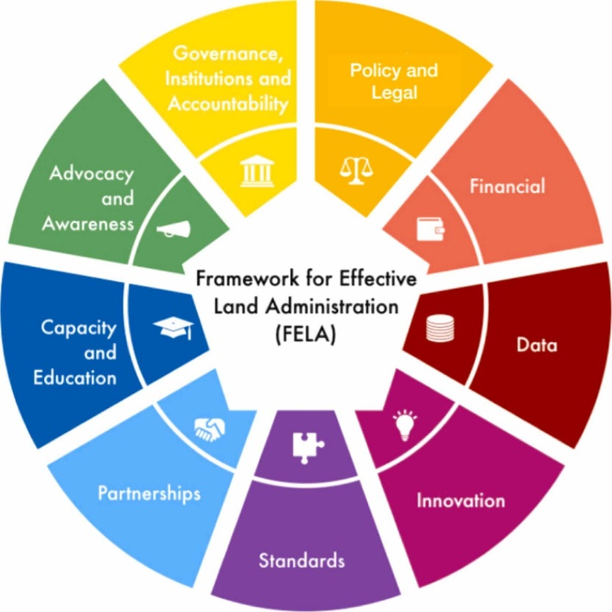
Figure 1. The 9 strategic pathways of FELA

Objectives
The objective of the workshop is to support Land Administration professionals and scholars in the Arab Region to increase their awareness, capacity, and advocacy on FELA, FFPLA, and Women’s access to land tools and approaches in local country contexts. It will do this by providing a single day event to demonstrate various in-country examples and developments, hardware, software, and processing solutions that enable FELA, FFPLA, and Women’s Access to land. The workshop will contribute to the ‘training of trainers’ efforts already undertaken by CRTEAN, ISTIDAMA and NELGA in the region.

Modality of implementation
The Workshop on FELA, FFPLA, and Women’s Access is organized by, KI, ITC and FIG and will be held in Rabat, Morocco. Where possible, it will incorporate private, public and NGO bodies to demonstrate and share experiences and best practices.

Key topics
The aim of the training is to provide tools for using the FELA, FFPLA and Women’s Access approaches in the Arab region and customize those to specific contexts. The training will be conducted by experts from KI, ITC, and FIG through demonstrations, interactive deliberations, presentations, group work and exercises.
The workshop will be hands-on, interactive, focusing on practical applications and in-depth exploration of the key pathways of the FELA – linked to FFPLA and women’s access - among professionals and students in land administration. Specifically, three key pathways that will be explored during the workshop include:
- Policy, Governance, and Accountability: Enhancing policy frameworks, enriching governance processes, and reinforcing accountability mechanisms for equitable land administration.
- Legal Frameworks: Exploring and assessing legal regulations in the Arab region.
- Financial Strategies: Exploring and assessing land valuation systems and sustainable financial models to support and sustain land administration in the Arar region countries

Expected Outcomes
The expected results of the training for participants are as follows:
- Understandings and awareness of the tenure security challenges in the Arab Region – including women’s access to land, and the principles and aspects of the application of FELA;
- Ability to analyse and select appropriate FELA tools within a given context;
- Knowledge on how to apply the key FELA pathways within specific countries, and importance of gender dimensions;
- Broader appreciation of the governance, legal, and institutional issues association with scaled FELA application.

Application Process
Deadline for applications is 17th January 2025
Interested people can send an email to Kadaster.international@kadaster.nl.
The selection criteria for attendance to the pre-event will be based on the resume provided. Women and young professionals are encouraged to apply. People who want to attend are encouraged to also register for the adjacent Arab Land Conference. Please indicate in your application if you are already registered for the Arab Land Conference from 18-20 February 2025, or wish to physically attend it as well.
Target participants
The target participants, include: Government representatives and administrators (land administration authorities, statistical department, surveying authorities, urban and rural planning departments, etc.), industry professionals (own costs) and NGO representatives.

Working Language
English will be the working language during the whole sessions of the training. It is also possible to use Arabic when necessary. Use of parallel translation services will be made possible.

Training Materials
After the event, all the materials used by the trainers and the trainees will be provided on request.

Logistics
The event will be held for one day will take place in Rabat, Morocco on 17 February 2025. The exact location will be shared with you in due course.

Further information
For any inquires or further information, please contact :
Luc Groot
Telephone: +31 6 3911 5466
Email address: Kadaster.international@kadaster.nl

Draft Schedule
Day 1 | Title | Description | Lead | Resources and Requirements
8:00  Session 0 | Arrival and Registration | - Registration desk and informal welcomes | LG/RB | - Coffee/tea  - lanyards; name tags, KI gifts
9:00  Session 1a | Welcome and Overview | - Facilitator and participant icebreaker  - Workshop aims and approach | LG/RB  M/A | - Meeting room  - Icebreaker materials  - Beamer; Flipcharts, Markers, sticky labels  - Circular room layout
9:15  Session 1b | Land Challenges in the Arab Region | - Overview presentation of key issues in land administration in Arab region  - Participants present national problems and cases (pre-prepared), with a specific focus on incomplete systems and women’s access to land | M/A | - Homework completed by participants (short slide deck)  - Framework for analysis (inc. women’s aspects)
10:30 | Break
11:00  Session 2a | FELA Pathways | - Introduction to FELA, 9 pathways, and emerging applications  - Zoom in on three key pathways  - Debate on FELA | KI | - Opening presentation, followed by structured debate activity
11:45  Session 2b | FELA Application | - Presentation of global GLTN, KI, and ITC case examples  - Discussion unpacking governance issues, success factors, failures | KI | - Documented FELA examples from Arab region and beyond  - flipcharts and sticky notes for the discussion (?)
12:30 | Lunch
13:30  Session 3a | FFPLA Frameworks | - Introduction FFPLA principles and 3 frameworks | ITC | - Opening presentation, followed by structured debate activity
14:15  Session 3b | FFPLA Applications and Emerging Technologies | - Overview of contemporary FFPLA applications in the region and globally. Critique on application and relevance to MENA region; small practical exercise (if possible) | ITC | - Documented FELA examples from Arab region and beyond  - flipcharts and sticky notes for the discussion (?)
15:00 | Break
15:30  Session 4 | Women’s Access to Land Forum | - Overview of land tools linked to women’s empowerment e.g., GLTN’s gender sensitivity criteria; FIG’s Publication 24  - Activity on key developments, successes, failures, and future outlook | GLTN? | - Overview of 2 decades of developments and outcomes  - Future outlook
16:30  Session 5 | Summary and Looking Ahead | - Key findings; Action plans per country | KI/ITC | - Flipcharts; Summary slides; graphical depiction?
17:00 | Close

